1890 501® Jeans

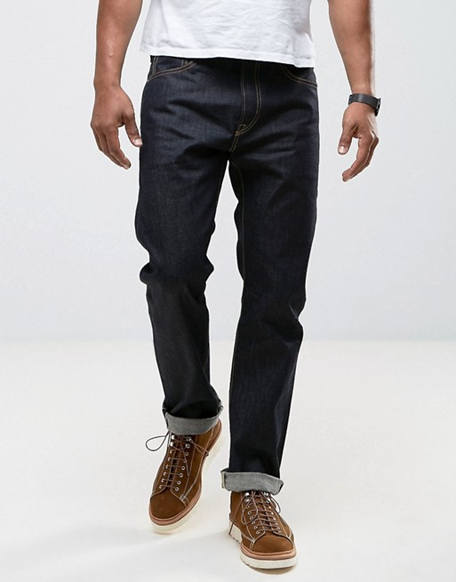
$285

DETAILS
1890 was the first year the 501® lot number was adopted. 1890 was the year that the 501® number was first assigned to the famous pants– likely done because the company no longer had an exclusive patent, and also because it had a good-sized line of clothing by this time. Any product made with the highest quality materials was given a lot number beginning with 5: 501® for the overall, 506 for the jacket, etc. Made with XX 9oz denim from the Amoskeag Manufacturing Company, the 501® pant was at the head of the class.

MATERIALS
- 100% Cotton
- Non-Stretch Denim
- Button Fly
- This garment has gone through a unique color dyeing process. Color transfer may occur onto other surfaces. This garment will fade and change appearance over time.
- Wash And Dry Inside Out With Like Colors; Liquid Detergent Is Recommended; Shrinkage In Wash Approximately 10%
- Imported

FIT & SIZING
- Sits at waist
- Regular fit through thigh
- Straight leg opening

